ShopNest Sales Dashboard Analysis Report
Introduction
This report presents a comprehensive analysis of ShopNest's sales performance using Power BI. The dashboard was developed to analyse product sales, delivery performance, customer payment preferences, regional sales distribution, seasonal sales patterns, product ratings, and overall revenue trends. The dashboard includes interactive visualisations, cards, and slicers to support business decision-making.
Task 1: Top Categories by Total Price
Question Statement: Identify and visually represent the top 10 product categories by total sales.
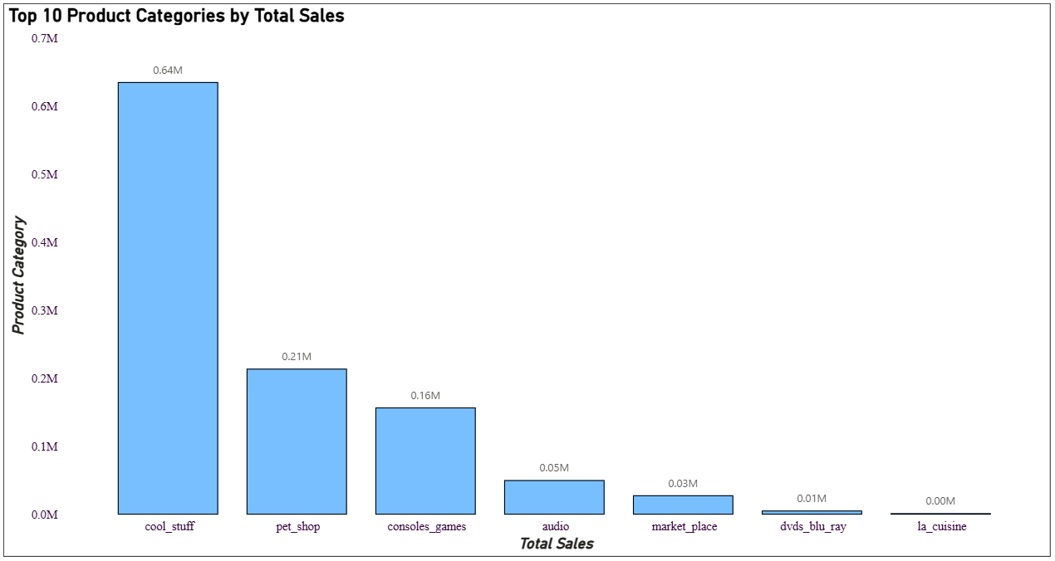
This visualisation displays the top 10 product categories based on total sales revenue. A column chart was used to compare sales across different product categories and identify the categories contributing the highest revenue to the business.
Key Insights and Findings
- A small number of product categories generate a significant portion of total sales.
- The highest-performing category (cool stuff) contributes substantially more revenue than the lower-ranked categories.
- The chart helps identify product categories that drive overall business performance.
Task 2: Delayed Orders Analysis
Question Statement: Determine the number of delayed orders in each category, and an order is considered delayed if the actual delivery date is later than the estimated delivery date.
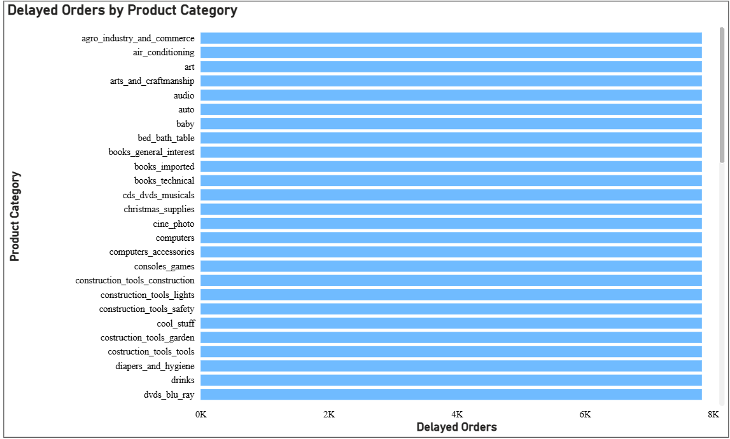
This horizontal bar chart displays the number of delayed orders across different product categories. The visualisation helps compare delivery performance among categories and identify which categories are affected by delivery delays. Each bar represents a product category and the corresponding number of delayed orders.
Key Insights and Findings
- Delayed orders are present across multiple product categories.
- Delivery delays are distributed among various categories rather than being limited to a single category.
- Monitoring delayed orders can help improve logistics and customer satisfaction.
- The visualisation provides a clear overview of categories affected by delivery performance issues.
Task 3: Monthly Comparison of Delayed and On-Time Orders
Question Statement: Create a dynamic visual that compares the number of delayed orders to the number of orders received earlier for each month. Utilise the drill-through cross-report feature to provide a detailed analysis of late and on-time deliveries.
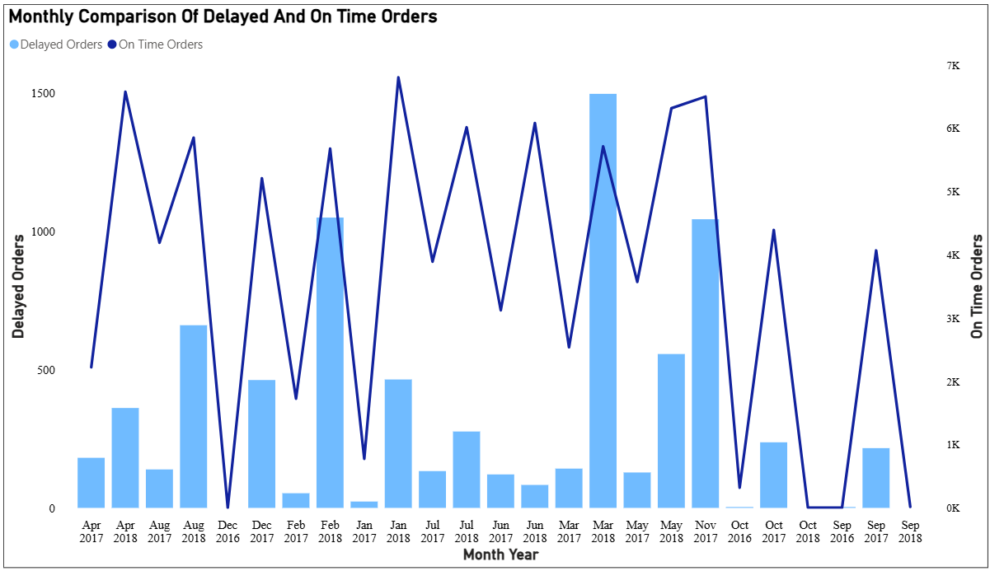
This visual compares delayed and on-time orders on a monthly basis. It helps evaluate delivery performance throughout the year and identify months with higher delivery issues.
Key Insights and Findings
- Delivery performance varies across different months.
- On-time deliveries generally exceed delayed deliveries.
- Some months show noticeable increases in delayed orders.
Task 4: Payment Method Analysis
Question Statement: Analyse the most frequently used payment methods by customers using a visually appealing representation, such as a pie chart or other suitable visuals.
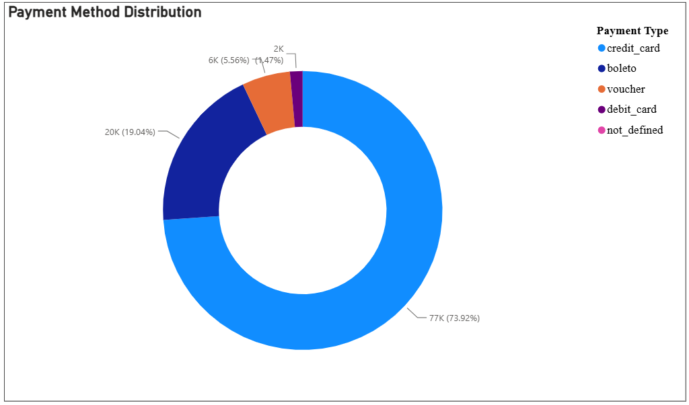
This visualisation illustrates the distribution of customer payment methods. A donut chart was used to compare the popularity of different payment options among customers.
Key Insights and Findings
- One payment method (credit card) is significantly more popular than the others.
- Customers show clear preferences when making purchases.
- Understanding payment preferences can improve customer experience and payment strategy.
Task 5: Product Rating Analysis
Question Statement: Determine the top-10 highest-rated and the bottom-10 lowest-rated products using a bar chart or column chart.
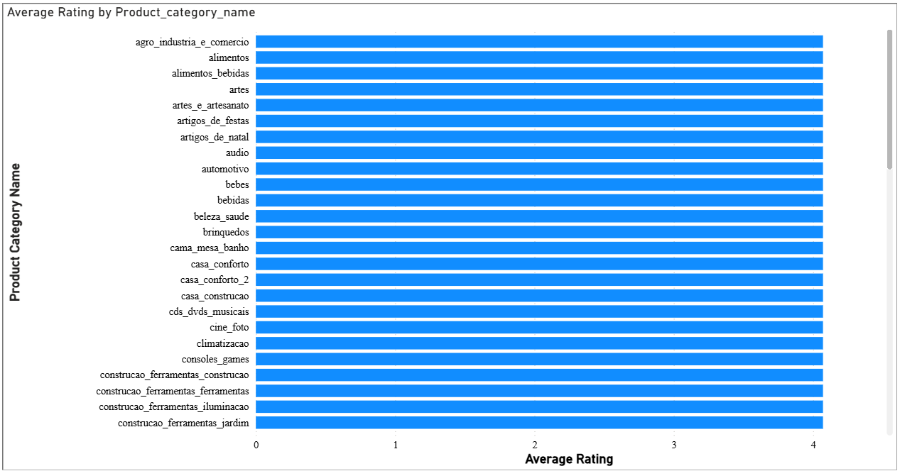
This bar chart shows the average customer rating across different product categories, based on review scores. The visualisation helps evaluate customer satisfaction levels and compare ratings across categories. The average rating for most categories is approximately 4 out of 5, indicating generally positive customer feedback.
Key Insights and Findings
- Most product categories have an average rating close to 4, reflecting good customer satisfaction.
- Customer ratings appear relatively consistent across categories.
- The overall review performance suggests that customers are generally satisfied with their purchases.
- Product ratings provide useful feedback for assessing product quality and customer experience.
Task 6: State-wise Sales Analysis
Question Statement: Identify and visually represent states with high and low sales, providing a clear understanding of regional sales performance.
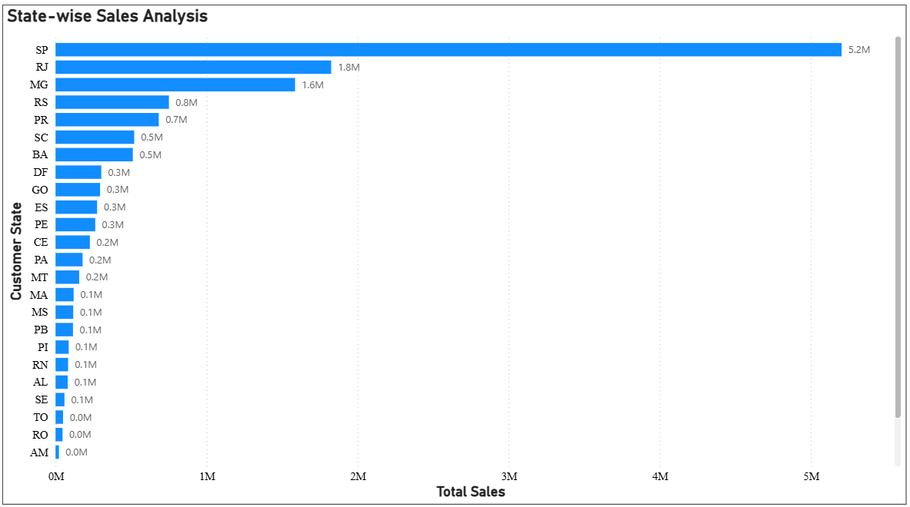
This visualisation compares total sales across different states. It highlights regional differences in sales performance and helps identify strong and weak markets.
Key Insights and Findings
- Sales are concentrated in a few states.
- Some states, such as SP, RJ, and MG, generate significantly higher revenue than others.
- Regional sales analysis supports targeted business strategies.
Task 7: Seasonal Sales Patterns
Question Statement: Investigate and visualise seasonal patterns (quarterly) and trends in sales data over the course of the year.
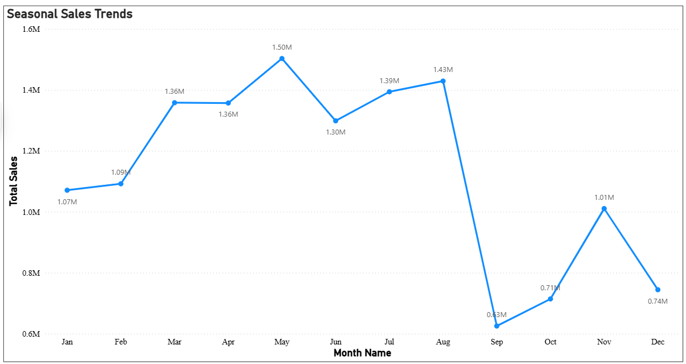
This line chart illustrates monthly sales trends throughout the year. It helps identify seasonal fluctuations and periods of higher or lower sales activity.
Key Insights and Findings
- Sales performance changes across different months.
- Certain months, such as March, May, and August, experience stronger sales activity than others.
- Seasonal patterns can help improve inventory and marketing planning.
Task 8: Revenue Analysis
Question Statement: Determine the total revenue generated by ShopNest and analyze how it changes over time (yearly). Represent this information through suitable visuals to highlight trends and patterns.
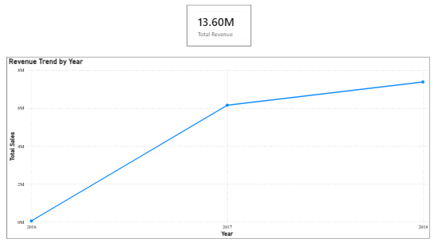
This visualisation displays revenue trends over the years and highlights the overall growth of the business. Cards were also used to summarise total revenue, total orders, and total customers.
Key Insights and Findings
- Total revenue generated by ShopNest is approximately $13.60 million.
- Revenue shows growth over time.
- The cards provide a quick summary of key business metrics.
Conclusion
The Power BI dashboard provides a comprehensive overview of ShopNest's business performance. Through sales analysis, delivery performance monitoring, payment method evaluation, customer ratings, regional sales analysis, seasonal trends, and revenue tracking, the dashboard offers valuable insights for decision-making. The use of cards, interactive visuals, and slicers enhances usability and supports data-driven business analysis.

